**Results**

**Development time Results**

**Egg to eclosion**

Egg to eclosion development time was calculated for each individual fly then compared between diet conditions and sex to ascertain their effect (Figure 1A). The graph suggests that males eclose slightly quicker than females and shows that SS flies are earliest to eclose. It also shows that AS flies are the slowest to eclose, with SA and AA flies eclosing at a similar rate. A Poisson log-link Generalised Linear Mixed Model was used to analyse the effect of the fixed factors of sex, long-term diet, and larval diet and to see whether an interaction exists between long-term diet and larval diet. The model included the random variables of fly line, eclosion plate, well within plate, and egg collection date. Egg collection date and eclosion plate were both shown to produce a small amount of variance whilst the others showed no effect. A strong interaction between long-term diet starch and larval diet starch was shown with SS flies reaching eclosion the fastest. This model was then used to calculate the mean number of days to reach eclosion for each diet treatment across males and females (Table 1). For each diet treatment, males developed slightly quicker than females. Like the graph suggested, SS flies developed the fastest with a mean day count of 20.1 for females and 19.9 for males, then AA flies with a mean day count of 21.1 for females and 20.9 for males, placing both at a day behind their SS counterparts.

However, this difference in development time could be due to differences in either egg to pupation time or pupation to eclosion time, so this was then explored.

**Table 1:** Mean number of days for eggs to develop to eclosion for different diet treatments for female and male flies. (Rate = number of days).

As above, egg to pupation development time and pupation to eclosion time were calculated for each individual fly then compared between diet conditions and sex (Figure 1B+C). The graph suggests that flies from long-term starch diet flies when raised on a larval diet of starch develop from egg to pupation the fastest. This egg to pupation development time for the long-term starch flies increases when placed on the more nutrient ASG larval diet. Long-term ASG flies also developed to pupation quicker when placed on their own diet, however, they still developed slower than SS flies. This was modelled the same as above but with only fly line and egg collection date as random variables, both of which produced a small amount of variance. The model showed that long-term starch diet increases the egg to pupae development time compared to an AA fly, but that larval starch diet increases the development time even more. However, a strong interaction between long-term starch diet and larval starch was shown so which decreased the development time of SS flies to even less than the AA fly. This model was then used to calculate the mean rate of pupation for each diet treatment across males and females (Table 2). For each diet combination, males pupated at a rate of 0.1 of a day quicker than their female counterparts.

**Table 2:** Mean number of days for eggs to develop to pupation for different diet treatments for female and male flies. (Rate = number of days).

The graph displaying the pupation to eclosion data shows no difference between the sexes and less difference in effect of both longterm and larval diet than in the egg to pupation graph, however SS flies do appear to on average eclose earlier than those from other diets. This was modelled using the same models as above, but with the random variables of fly line, eclosion plate, well within plate, and egg collection date, and only egg collection date caused a small amount of variance. The model also showed that males developed slightly quicker than females and that AS and SA flies developed faster than AA flies. SS flies again developed the fastest, and an interaction effect was shown by the model, but it was smaller than that shown by the egg to pupae data. Means data from this model showed than the mean number of days for SS flies to develop from pupation to eclosion was 9.59 for females and 9.52 for males, whilst for next fastest, AS was 9.81 for females and 9.73 for males (Table 3). Therefore, pupation to eclosion rate appears less effected by sex, long-term diet, or larval diet than development to pupation.

Table 3:** Mean number of days for eggs to develop to pupation for different diet treatments for female and male flies. (Rate = number of days).

Figure 1:

**Eclosion to egg laying/ Egg to egg laying**

Using just data for the flies placed into cages, where each cage contained flies from the same pupation date, overall development time from first eclosion in cage to first egg laying was calculated for each cage and development time from egg to first egg-laying was calculated for each cage. These development times were then compared across larval and long-term diet combinations (*Figure* 2). A Poisson log-link Generalised Linear Model was also used for both of these analyses to explore the effect of the fixed factors of long-term diet and larval diet and to see whether an interaction exists between them. General Linear Mixed Models found that random factors fly line and f2 egg collection date showed no effect on either eclosion to egg laying time or egg to egg-laying time so were removed from the final model.

Using a Chi-squared test, the final model for first eclosion to first egg-laying time showed that compared to AA flies, SA flies and AS flies showed no significant difference in time [95% CI: 2.564-6.13] (Poisson GLM: =34.93, *P*=0.424?????), [95% CI: 2.456-5.88] (Poisson GLM: = 29.02, *P*=0.782????), respectively. It was also show that there was no significant interaction effect between larval starch and long-term starch diets [95% CI: 3.582-9.79???????] (Poisson GLM: =32.90??????, *P*=0.652????).

The final model from f2 egg collection to f2 egg laying ????? says p>0.05 for all.. but graph clearly shows SS quickest 🡪 low N number?? (9or 8 for each diet treatment)

Figure 2:

**Pupae to adult survival**

To measure pupae to adult survival number of number of successful eclosions was compared to number of unsuccessful (either uneclosed or partially eclosed pupae), this was them compared between the different diets (Figure 3…….not done……………). A Binomial Generalised Linear Mixed Model was used to with larval diet and long-term diet as fixed effects and fly line, eclosion plate, eclosion well and f2 egg collection date as random effects. All random variables were shown to have an effect, especially egg collection date and plate. The large effect of plate could suggest that light influences likelihood of eclosion. The model showed that SS flies had the highest probability of eclosion with a probability of 0.938, followed by AA (0.932), then SA (0.927), then AS (0.886). The model showed a strong interaction effect between long-term starch diet and larval starch diet. However, the only significant difference was between AA flies and AS flies, where AA flies were more likely to eclose (Table 4).

Table 4:

**Egg size, egg number and female weight**

**Egg volume:**

linear mixed model: SS biggest AA smallest --- significant contrasts!! ANOVA Fly line produce variance

**Egg number**

Egg count for each cage was divided by number of females per cage. (Figure 4B). Linear mixed model used – fixed effects: larval diet and long-term diet; random effects: fly line. AA highest mean egg count (35.7), then AS (32.4), followed by SS (27.9) and SA (26.5)(Table 6). An ANOVA test on the model showed that there wasn’t an effect interaction between long-term diet and larval diet and that larval diet and long-term diet didn’t effect egg number (Table 7).

Table 6: Egg count per female

Table 7: ANOVA of Egg count per female

DOES FLY LINE HAVE HIGH VARIANCE????

**Female weight**

Figure 4C. Linear mixed model. AA heaviest mean (3.46mg), then AS (3.16), followed by SS (3.07) and SA (3.01). Means contrasts show (……). Model showed interaction effect between longtermdiet starch:larval diet starch. Fly line produced quite high deviance

Figure 4:

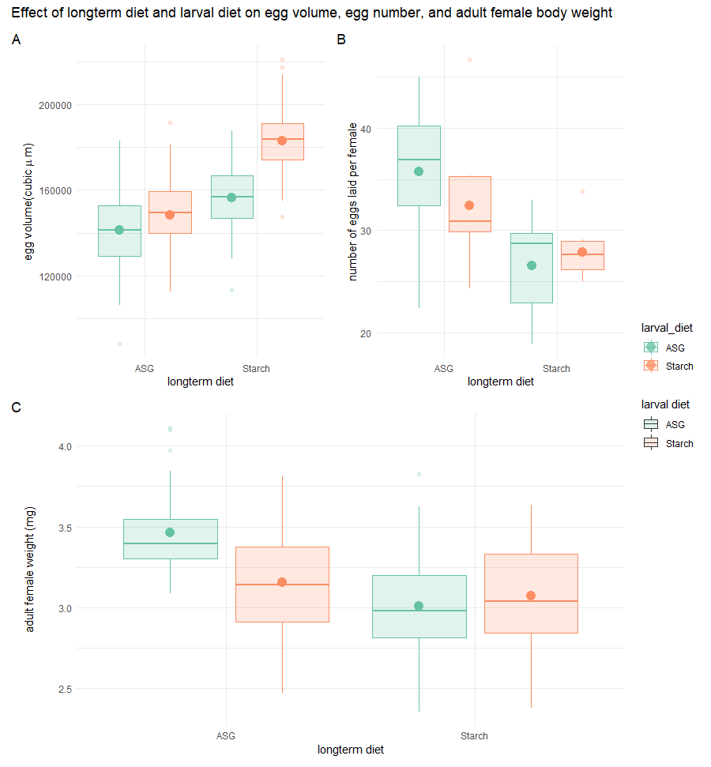

All analyses were carried out in RStudio (Version 1.3.1093) with the following packages: lme4 (….), lmerTest (…) and emmeans (….) for modelling; and tidyverse (Wickham et al 2019), performance (Lüdecke et al 2021) for checking model assumptions.